Life Science Final Project: LS-180
For your final assessment, you will be required to create a 180-second video relating to a topic or lesson of your choice that we covered this year. The video must be educationally based and thoroughly teaches a concept to beginning learners. Your video can be a music video, play, claymation, animation, TV show, interview, demonstration or another style.
The project may be done in small groups (up to 3), pairs or individually. A percent of the grading will be done by students in lower grades who will assess the video based on its content, clarity and creativity. Make the video easy to understand by younger students who have not learned about the topic!
The assignment will be worth a total of 85 points.
Important Dates:
* May 7th: I will need your topic and group members (if applicable).
* June 4th: Due date for completion of video.
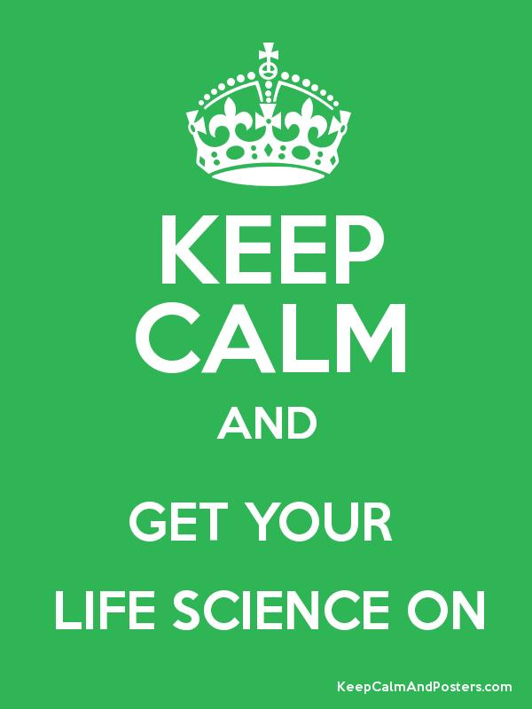
You will be given a specific link to place your videos upon completion. You may use either a PC or Mac based program to create your video. There will be some time in class to work on this, however the majority of this project will be done outside of class. The attached rubric should be followed to receive full credit.

 | Poor  1 pts | Good-Fair  2 pts | Good-Excellent  3 pts
Content  pts weighted X 7 | Poor  The video weakly defines a life science concept, but it is not appropriate for the audience or is vague in its explanations. | Good-Fair  The video partially demonstrates a life science concept but does not clearly teach the topic to the audience. | Good-Excellent  The video clearly and thoroughly teaches a life science concept. The video should either assist in teaching a concept to beginners or help a person that just learned the content remember it.
Accuracy  pts weighted X 5 | Poor  There are several life science inaccuracies in the video. | Good-Fair  There are one or more life science inaccuracies in the video. | Good-Excellent  All life science facts are accurately represented in the video.
Clarity  pts weighted X 4 | Poor  The audience has difficulty understanding the video. The explanation of the topic is difficult to understand. | Good-Fair  The audience is able to understand most of the text/audio if the video easily. Most of the explanations are easy to understand. | Good-Excellent  The audience is able to easily understand the text/audio of the video. Explanations of life science concepts are easily understood.
Creativity  pts weighted X 4 | Poor  Video is uninteresting, lacking in creativity, or appears that little time was taken in its production. | Good-Fair  Video is somewhat creative and interesting. It is clear that some time and effort were dedicated to making the video unique. | Good-Excellent  Video is exceptionally creative and interesting. It is clear that significant time and effort were dedicated to making the video unique.
Quality/Presentation  pts weighted X 3 | Poor  The video appears haphazard and of low quality. | Good-Fair  Video is well put together, props are used appropriately, music and sound effects are applied. | Good-Excellent  Video is exceptionally well put together, props are used appropriately, music and sound effects are applied.
Timing  pts weighted X 2 | Poor  Video is under 180 seconds in length. | Good-Fair  Video is over 180 seconds in length. | Good-Excellent  Video is within 3 seconds of 180 (and there is no obvious "filler").
Top of Form

GRADING RUBRIC – SCIENCE VIDEO
Please circle the number below each question that reflects what you thought of the video. There is a space for additional comments for you to use.

Video Title: ___________________________________________________
Student Name(s): ________________________________________________

1. How much did you learn by watching the video?
2 - A lot. The video was interesting and I learned several new things about the topic.
1 - A little bit. Parts of the video were interesting and I learned a few new things about the topic.
0 - Not much. The video was not very interesting and I did not learn anything new about the topic.

2. Did this video make you want to learn more about the topic?
2 - Yes.
1 - A little bit.
0 - Not much.

3. Could you explain this video to a friend?
2 - Yes, I understood the video well enough to explain it to a friend.
1 - I understood most of the video well enough to explain it to a friend.
0 - I would have a hard time explaining most of the video to a friend.

4. Was the video creative?
2 - Yes the video was very creative.
1 - Most of the video was creative.
0 - Only parts of the video were creative.

5. Did the video make you more interested in science?
2 - Yes
1 - A little bit
0 - Not much

Please add any additional comments below:
__________________________________________________________________________________________________________________________________________________________________________________________________________________________________________________________________________________________________________________________________________________________________________________________________________________________________________________________________________________________________________________________________________________________________________________________________________________________________________________________________________________________________________

